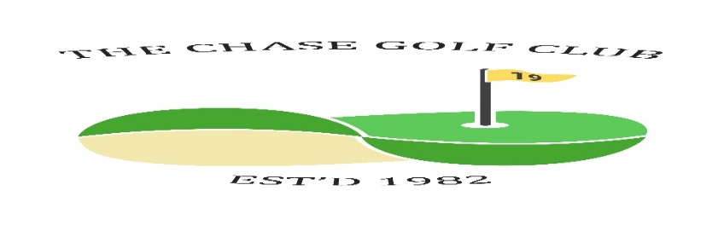
The Chase Golf Club

Competition Draw Sheet - May Medal + Qualifier 2
Dates: Wed May 7th Fri 9th Sat 10th Sun 11th Venue Seafield

Time &  initials | Wednesday Draw
 | J Brodie | S Smith | D Edgar
 | J Burnett | R Lees | G Cavanagh
pm | A Smeeton | John Kelly | W Barclay
Time &  Initials | Friday Draw
Time &  initials | Saturday Draw
 | S Kirk | D Beattie | S Hannah
 | A Muir | R Greenwood | M Mancini | T Bloor
Time &  initials | Sunday Draw
 | I Speirs | S Cairns | P Middleditch
 | E Borland | W Rae | M Duffy
pm | R Gilchrist | J Taylor | J Cathcart | I Gray
Now the draw has been made you are not able to change days without express consent from a Committee member under the permitted playing conditions. Failure to contact a Committee member will lead to disqualification.
Format | 18 holes white | Handicaps | Strokeplay  Max 28 | Prizes | More than 10 players 1/2/3  Less than 10 players 1/2  Less than 5 is winner only
N.B. If you withdraw from a game, then you must contact all players in your group to let them know. Failure to do so will result in players left without a game and the Committee will take action against offender(s).

